LAB 3
Title: SQL constraints
Objective: To be familiar with constraints in SQL and Implementing it
Theory:
- SQL constraints are used to specify rules for the data in a table.
- Constraints are used to limit the type of data that can go into a table.
- This ensures the accuracy and reliability of the data in the table. If there is any violation between the constraint and the data action, the action is aborted.
The following constraints are commonly used in SQL:
NOT NULL - Ensures that a column cannot have a NULL value
UNIQUE - Ensures that all values in a column are different
PRIMARY KEY - A combination of a NOT NULL and UNIQUE. Uniquely identifies each row in a table
FOREIGN KEY - Prevents actions that would destroy links between tables
CHECK - Ensures that the values in a column satisfies a specific condition DEFAULT - Sets a default value for a column if no value is specified

NOT NULL
- By default, a column can hold NULL values.
- The NOT NULL constraint enforces a column to NOT accept NULL values.
- This enforces a field to always contain a value, which means that you cannot insert a new record without adding a value to this field.

- create table with NOT NULL constraint.
Example:
CREATE TABLE Colleges ( college_id INT NOT NULL, college_code VARCHAR(20),
college_name VARCHAR(50)
);

- Add the NOT NULL constraint to a column in an existing table
Example:
ALTER TABLE Colleges
MODIFY COLUMN college_id INT NOT NULL;

- Remove NOT NULL Constraint
Example:
ALTER TABLE Colleges

MODIFY college_id INT
;

UNIQUE
✓ The UNIQUE constraint ensures that all values in a column are different.

❖ Create a table with unique constraint

Example
CREATE TABLE Colleges ( college_id INT NOT NULL UNIQUE, college_code VARCHAR(20) UNIQUE,
college_name VARCHAR(50)
);

❖ Add the UNIQUE constraint to an existing column
For single column

Example
ALTER TABLE Colleges
ADD UNIQUE (college_id);

For multiple columns

Example
ALTER TABLE Colleges
ADD UNIQUE Unique_College (college_id, college_code);
- Here, the SQL command adds the UNIQUE constraint to college_id and college_code columns in the existing Colleges table.
- Also, Unique_College is a name given to the UNIQUE constraint defined for college_id and college_code columns.

❖ DROP a UNIQUE Constraint

Example
ALTER TABLE Colleges
DROP INDEX Unique_College;

PRIMARY KEY
- The PRIMARY KEY constraint uniquely identifies each record in a table.
- Primary keys must contain UNIQUE values, and cannot contain NULL values.

- Create table with PRIMARY KEY constraint Syntax:
CREATE TABLE table_name ( column1 data_type,
............................,
[CONSTRAINT constraint_name] PRIMARY KEY (column1)
);

Example
CREATE TABLE Colleges (
college_id INT,
college_code VARCHAR(20) , college_name VARCHAR(50),
CONSTRAINT CollegePK PRIMARY KEY (college_id)
);
//Create Colleges table with primary key college_id
- Add the PRIMARY KEY constraint to a column in an existing table
Example
ALTER TABLE Colleges
ADD CONSTRAINT CollegePK PRIMARY KEY (college_id);

- DROP a PRIMARY KEY Constraint
Example
ALTER TABLE Colleges
DROP PRIMARY KEY;

CHECK
- The CHECK constraint is used to limit the value range that can be placed in a column.
- If you define a CHECK constraint on a column it will allow only certain values for this column.

- CHECK constraint while creating table
Example:
Here we are Applying the CHECK constraint named amountCK the constraint makes sure that amount is greater than 0.
CREATE TABLE Orders ( order_id INT PRIMARY KEY,
amount INT,
CONSTRAINT amountCK CHECK (amount > 0)
);

- Add CHECK Constraint in Existing Table
Here we add CHECK constraint named amountCK the constraint makes sure that amount is greater than 0.
ALTER TABLE Orders
ADD CONSTRAINT amountCK CHECK (amount > 0);

- Remove CHECK Constraint
ALTER TABLE Orders
DROP CONSTRAINT amountCK;

DEFAULT
- the DEFAULT constraint is used to set a default value if we try to insert an empty value into a column.
- However if the user provides value then the particular value will be stored.

- Default constraint while creating table
The following example set default value of college_country column to 'Nepal' Example:
CREATE TABLE College ( college_id INT PRIMARY KEY, college_code VARCHAR(20),
college_country VARCHAR(20) DEFAULT 'Nepal'
);

- Add the DEFAULT constraint to an existing column
Example:
ALTER TABLE College
ALTER college_country SET DEFAULT 'Nepal';

- Remove Default Constraint
Example:
ALTER TABLE College
ALTER college_country DROP DEFAULT;

FOREIGN KEY
The FOREIGN KEY constraint in SQL establishes a relationship between two tables by linking columns in one table to those in another.
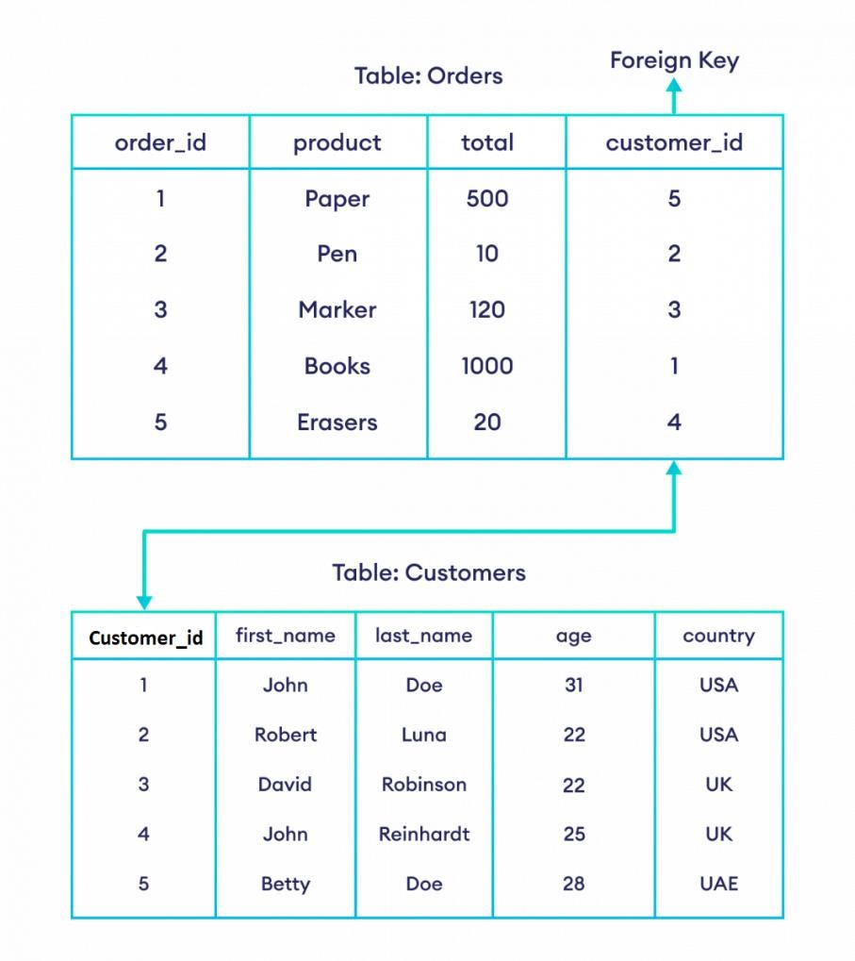
- Here, the customer_id field in the Orders table is a FOREIGN KEY that references the customer_id field in the Customers table.
- This means that the value of the customer_id (of the Orders table) must be a value from the customer_id column (of the Customers table).

The syntax of the SQL FOREIGN KEY constraint is:
CREATE TABLE table_name ( column1 data_type, column2 data_type,
…………………………..,
[CONSTRAINT CONSTRAINT_NAME] FOREIGN KEY (column_name)
REFERENCES referenced_table_name (referenced_column_name)
);
Here,
- table_name is the name of the table where the FOREIGN KEY constraint is to be defined
- column_name is the name of the column where the FOREIGN KEY constraint is to be defined
- referenced_table_name and referenced_column_name are the names of the table and the column that the FOREIGN KEY constraint references
- [CONSTRAINT CONSTRAINT_NAME] is optional
Let us see with following example
- This table doesn't have a foreign key
- add foreign key to the customer_id field
- the foreign key references the id field of the Customers table
-- this table doesn't have a foreign key

CREATE TABLE Customers ( customer_id INT, first_name VARCHAR(40),
last_name VARCHAR(40), age INT,
country VARCHAR(10),
CONSTRAINT CustomersPK PRIMARY KEY (customer_id)
);
-- add foreign key to the customer_id field
-- the foreign key references the id field of the Customers table
CREATE TABLE Orders ( order_id INT, product VARCHAR(40),
total INT,
customer_id INT,
CONSTRAINT OrdersPK PRIMARY KEY (order_id),
CONSTRAINT CustomerOrdersFK FOREIGN KEY (customer_id) REFERENCES Customers(customer_id)
);

Add the FOREIGN KEY constraint to an existing table
✓ add foreign key to the customer_id field of Orders the foreign key references the customer_id field of Customers
ALTER TABLE Orders
ADD FOREIGN KEY (customer_id) REFERENCES Customers(customer_id);

Remove a FOREIGN KEY Constraint
ALTER TABLE Orders
DROP FOREIGN KEY CustomerOrdersFK;

Now let update customer table, update customers set name='gita' where customer_id=3; Again insert some rows in orders table
insert into orders values(1,'iron',1200,1); insert into orders values(2,'guitar',4500,2); insert into orders values (3,'phone',57000,1); insert into orders values(4,'printer',88000,3); insert into orders values(5,'drone',125000,2); insert into orders values(6,'smartwatch',7500,4);
insert into orders values(7,'oven',14500,5);

Now, table looks like
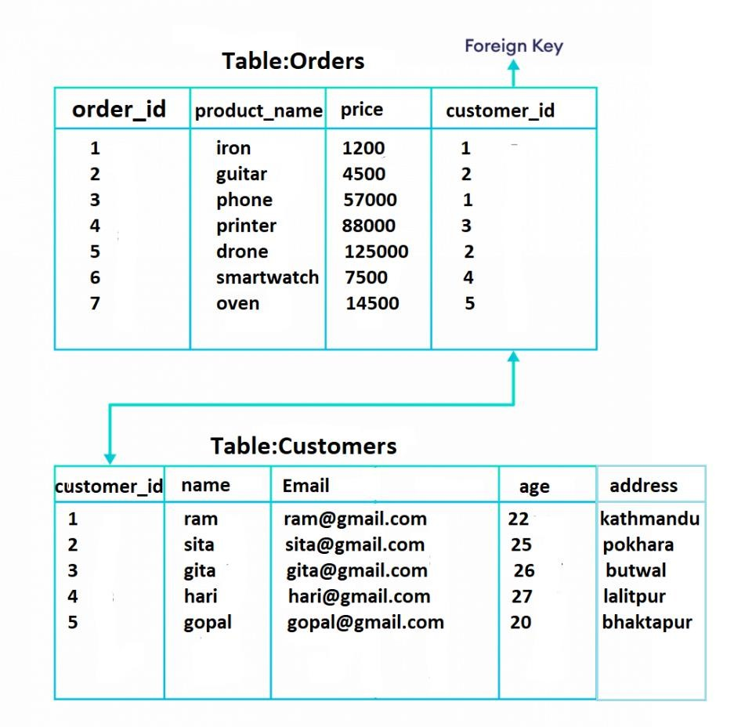
Try to insert customer_id in orders table that does not exist in customers table insert into orders values(8,'Laptop',158000,6);
This cannot be inserted, because it violates foreign key consraints.

Prepared By: Pradip Paudel
Discussion: (This portion is left for student)

Conclusion: (This portion is left for student)

*******THE END*******
Prepared By: Pradip Paudel

